|  |
| --- |
| **Dementia Inclusive Communities – partner and champion press release template**  **Notes**   * **Please download and save a new version of this document.** * **Review and replace the highlighted sections with details of your own event or activity.** * **You can also update this release to promote regular dementia inclusive activities such as meetings, walks, exercise classes, dementia cafes, singalongs and choirs.** * **If using after an event/activity, update tense throughout and edit the quote to thank people for attending and to celebrate the success of the event/activity.** * **Remember to include:**   + **Dates**   + **Times**   + **Venues**   + **Booking information**   + **Contact information for your dementia alliance, organisation, business or community group** * **Please delete these notes, remove examples and highlighted text before sharing with local news and radio contacts.** |

**Your dementia alliance, organisation, business or community group name press release**

**Date**

**Heading (for example – Building a Dementia Inclusive XX, Dementia Awareness/Information Event planned in XX, Join us for a Dementia Inclusive Event/Activity in XX)**

The (insert name of your dementia alliance, organisation, business or community group) are inviting residents, businesses, community groups and clubs to join them to learn more about dementia and the practical steps we can all take to help build a more inclusive community for people with dementia and their families in (insert location).

The (insert name of event or activity) will take place on (insert date) at (insert venue or online option) on (insert date) from (insert time). The event is free to attend and everyone is welcome.

Edit as needed…Guest speakers include (insert name of anyone invited to speak). As well as speakers, there will also be representatives and information and advice from local organisations such as (insert names of any organisations or groups who have agreed to attend with information about a local service or support).

More than 64,000 people are living with dementia in Ireland and this figure is increasing meaning more and more of us will be affected, or know someone who has been affected by dementia in our lifetime. The majority of people with dementia live in the community. There are lots of organisations and services in XX and the surrounding areas, which are already inclusive; however, there is huge potential to build on this and support XX to create a Dementia Inclusive Community. This event/activity will provide some practical advice on actions we can all take to consider and welcome people with dementia and their families in community life.

Edit quote as needed from this example…Sheena Cadoo, Occupational Therapist, Memory Technology Resource Room, Cork Kerry Community Healthcare, explained

“This is a wonderful opportunity to bring the entire community together to learn more about dementia and the simple things we can do to improve the lives of our friends, neighbours, and customers who may be affected by the condition. Working together – building that understanding and awareness, we can ensure that people with dementia and their family members can stay connected and feel supported in their environment”

(Insert name of your dementia alliance, organisation, business or community group) is working alongside the Dementia: Understand Together campaign. Led by the HSE, Dementia: Understand Together partners with The Alzheimer Society of Ireland, Age Friendly Ireland, Age & Opportunity, Dementia Services Information and Development Centre and Healthy Ireland, and encourages community members and national organisations to make their communities more dementia inclusive.

If you’d like to find out more about (insert name of activity or event) and how you can help to create a Dementia Inclusive community in XX, please (insert contact details of your dementia alliance, organisation, business or community group)

ENDS

For more information and local spokesperson available, to arrange please contact:

* **Name, email, phone number**

**Notes to Editors**

Add any additional notes about your organisation or initiative here.

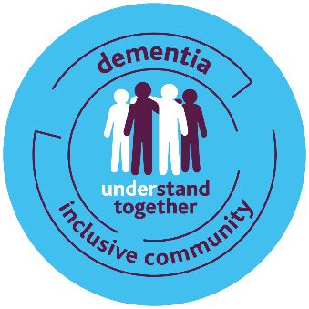

* The national Dementia: Understand Together campaign aims to inspire people from all sections of society to stand together with more than 500,000 people whose families have been affected by dementia in Ireland. Led by the HSE in partnership with The Alzheimer Society of Ireland, Age Friendly Ireland, Age and Opportunity, the Dementia Services Information and Development Centre and Healthy Ireland, the campaign is supported by over 40 partner organisations, including retail, transport, banking, health, voluntary and community sectors. These organisations, together with more than 1,200 community champions from across Ireland, are leading the way in creating dementia inclusive communities.

For more information, please visit [www.understandtogether.ie](http://www.understandtogether.ie) or email the team at [understandtogether@hse.ie](mailto:understandtogether@hse.ie)