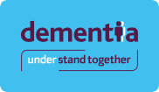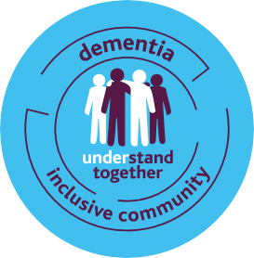

**Communications guidance and templates – A toolkit for Partner Organisations and Community Champions**

Thank you for joining the Dementia Understand Together campaign. Whether you are new to the campaign or have been with us from the start, we are so grateful for your support.

Community champions and partner organisations ranging from retail, transport, banking, health and the voluntary and community sector are all taking action to create dementia inclusive communities. Together we are striving to create communities that respect, include and support people living with dementia, their families and supporters.

By sharing your stories, you are raising awareness of your dementia inclusive actions, initiatives and projects and inspiring your communities to come behind your work and to take action themselves.

**This guide contains everything you need to support the development of your communications and promotional materials.**

You’ll find more information, training and can order additional resources at: [**www.understandtogether.ie/get-involved**](http://www.understandtogether.ie/get-involved)

If you need further support to help you display the symbol, would like to discuss training needs or have a branding or promotional question, please email: [**understandtogether@hse.ie**](mailto:understandtogether@hse.ie)

By inspiring people to understand and value a person’s inclusion, we can encourage them to take meaningful actions which can positively affect a person’s quality of life.

Through your help to make our communities inclusive for people living with dementia, we are creating an environment that will lead to inclusive communities for everyone.

Thank you.

**Fiona Foley**

National Coordinator, Dementia: Understand Together in Communities HSE National Dementia Services

**This guide covers:**

**The power of storytelling 3**

**Social media guidance and templates 4**

**Guidance for creating posters and flyers 7**

**Using images to help tell your story 9**

**Dementia inclusive and accessible language 11**

**Using the Dementia Inclusive Community symbol in your communications and promotions 12**

# **The power of storytelling**

To create dementia inclusive communities all over Ireland, we need people like you to help us spread the word and inspire others.

**There are some simple ways you can help:**

* Send us your photos and videos with the dementia inclusive community symbol being used. Whether you organise an event or activity or simply add the symbol to the front of your premises, meeting place, website or promotional materials – please take some photos or even a short video that you can share with us to use in our newsletter and on social media.
* Remember, if you include people, you need to ask their permission to share their image. You can use the HSE consent forms for anything you are planning to share with us at [www.hse.ie/branding](http://www.hse.ie/branding)
* Tell us your story – we’re always looking for people to share their experience of being a champion or partner.

As well as supporting the campaign, this can also provide a good promotional opportunity and highlights your efforts, or those of your organisation, to your local community and beyond. Share your stories and get advice and support at: [**understandtogether@hse.ie**](mailto:understandtogether@hse.ie)

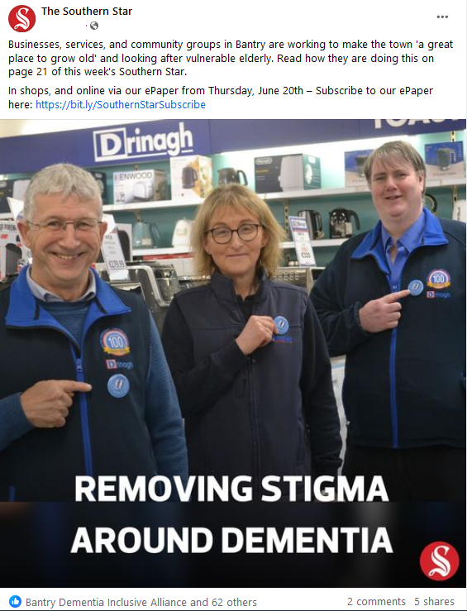**Some examples of great storytelling from our Partners and Community Champions:**

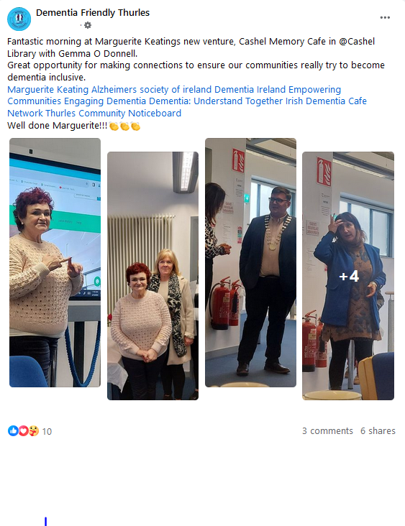

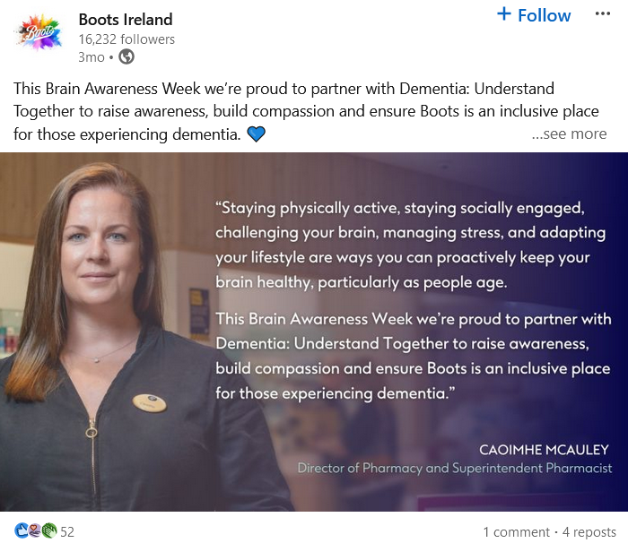

**You can download a template press release here:**

[**www.understandtogether.ie/training-resources/training-and-resources.html**](http://www.understandtogether.ie/training-resources/training-and-resources.html)

# **Social media guidance and templates**

Social media is a great, and often free, way to help share your messages and updates with your followers and local community.

Less is more when trying to catch people’s attention so don’t write long, text heavy posts. Try to keep your messages simple and informative and use images and videos to help with engagement.

Please tag us in your social media posts so that we can share and like.

**Our social media accounts to tag are:**

1. **facebook.com/dementiaunderstandtogether**
2. **twitter.com/dementia_office**

**Hashtags can help people search for content, the ones we use regularly are:**

**#UnderstandTogether**

**#DementiaInclusiveCommunities**

If you have a Facebook page or Instagram account, follow these accounts to keep updated with dementia, brain health and health services news across the country:

|  |  |  |
| --- | --- | --- |
| **Organisation** | **Twitter/X** | **Facebook** |
| Dementia: Understand Together campaign  official accounts  (Our Twitter/X account is managed by the HSE’s National Dementia Services) | @dementia_office | @dementiaunderstandtogether |
| Alzheimer Society of Ireland (ASI) | @alzheimersocirl | @TheAlzheimerSocietyofIreland |
| Age Friendly Ireland | @AgeFriendlyIrl | @AgeFriendlyIrl |
| Dementia Services Information and Development Centre | @DSIDCDementia | @DementiaDSIDC |
| Age & Opportunity | @Age_Opp | @AgeandOpportunity |
| Healthy Ireland | @HealthyIreland | @healthyireland.gov.ie |
| HSE | @hselive | @HSElive |
| Engaging Dementia | @EngagingDemIrl | @EngagingDementiaIreland |
| Family Carers Ireland | @CarersIreland | @familycarers |
| Alone | @ALONE_IRELAND | @ALONEIreland |

**Individuals**

There may also be some dementia specific related services and supports that use social media in your local area, you can search for these or look at some of the pages or accounts that national organisations are following.

Please like and share positive posts about dementia whenever you can, it helps to raise awareness and many pages and accounts will appreciate your support.

**Organisations, businesses and community based groups**

Most businesses and organisations have a social media page or account.

As well as liking and following the national accounts above, it’s a good idea to follow community groups, pages and other business accounts in your local area to share relevant dementia awareness and dementia inclusive posts from.

This is a quick and easy way to keep your page active and relevant and you’ll also be supporting other groups, businesses and organisations to amplify their messages which they’ll likely do in turn for you.

**Using images and videos on social media**

If you have any relevant photos or videos from your dementia related activity or actions, please share them with your social posts.

Photos, images and graphics help your posts to stand out to your friends and followers. They also help improve engagement if you’re promoting your work/efforts, an event or activity.

Where possible, videos should be no more than 60 seconds and ideally just 30-40 seconds. If you have a longer video you’d like to share, you could use a short snippet of it first to draw people in.

There are some general images to accompany social media posts at: [**www.understandtogether.ie/training-resources/training-and-resources.html**](http://www.understandtogether.ie/training-resources/training-and-resources.html)

**Template social media posts**

Here you’ll find some template social media posts that you may be useful. Please edit highlighted text and edit further to meet your needs.

If you’d like to say something more specific or need advice, please email the campaign team on: [**understandtogether@hse.ie**](mailto:understandtogether@hse.ie)

**Dementia: Understand Together campaign:**

|  |  |
| --- | --- |
| **Facebook/Instagram** | **Twitter (X)** |
| I’m/We’re proud to be part of Dementia: Understand Together, a national campaign to raise awareness for dementia and show solidarity and support for over 64,000 people living with dementia in Ireland and their loved ones.  Working together, we aim to help people’s understanding of dementia and to build #DementiaInclusiveCommunities where people with dementia can feel welcome, connected and included in community life.  #UnderstandTogether | I’m/We’re proud to be part of Dementia: Understand Together, a national campaign to raise awareness for dementia and show solidarity with over 64,000 people living with dementia in Ireland. We aim to build #DementiaInclusiveCommunities where people feel welcome and included. |

**Dementia Inclusive Communities:**

|  |  |
| --- | --- |
| **Facebook/Instagram** | **Twitter (X)** |
| The majority of people with dementia in Ireland live in the community. The #DementiaInclusiveCommunity symbol was developed with people with dementia at it’s heart.  I’m/We’re using it to raise awareness for dementia and show that we’re committed to working together with our staff/volunteers/customers to make our area/service/group as inclusive as possible for people with dementia and their families.  Wherever you see this symbol there is support for people with dementia.  #UnderstandTogether | The majority of people with dementia live in the community. I’m/We’re using the #DementiaInclusiveCommunity symbol that has been created with people with dementia at its heart to raise awareness for dementia and for my/our commitment to make our area/business/service as inclusive as possible. |

**Your own event or activity:**

|  |  |
| --- | --- |
| **Facebook/Instagram** | **Twitter (X)** |
| I’m/We’re holding a (insert name of event or activity) on (insert date) at (insert venue) from (insert time). Join me/us to find out more about dementia/take part in this dementia inclusive activity. It’s free to attend and everyone is welcome.  #UnderstandTogether #DementiaInclusiveCommunities | I’m/We’re holding a (insert name of event or activity) on (insert date) at (insert venue) from (insert time). Join me/us to find out more about dementia/take part in this dementia inclusive activity. It’s free to attend and everyone is welcome.  #UnderstandTogether #DementiaInclusiveCommunities |

# **Guidance for creating posters and flyers**

Posters and flyers are a great additional promotional tool to help your event or activity stand out.

As well as printing a poster and asking local businesses and services to display, you can send it to local press and other contacts by email and use it as a social media image.

**Free design tool:**

If you’re not already signed up, it may be helpful to use an online design platform like Canva to help you develop images, flyers and posters.

Basic accounts are free and you can upload your own images and logos to use on your designs and schedule your social media posts using the site. There are also paid ‘pro’ subscriptions that allow you to access more graphics and content so make sure you’re only signing up to the account type you’re comfortable with.

[www.canva.com](http://www.canva.com)

**Top tips for creating a great poster or flyer:**

* Don’t overcrowd your poster/flyer with too many images, graphics or too much text - include an even amount of clear/blank space
* Use headings, short sentences, simple words, and bullets to illustrate your points with relevant images or graphics to break up text and draw people in
* Keep it simple; only include the details you really need people to see, rather than explaining everything before your event or activity
* Most posters will be A3 or A4 in size, some flyers are A5
* Use fonts that are accessible such as Arial, Calibri or Helvetica. Font size should be a minimum of pt. 14, headings can be larger
* Use colours that compliment your images and logo and make sure there is enough contrast that your text is accessible to read.

**Example of a poster or flyer:**

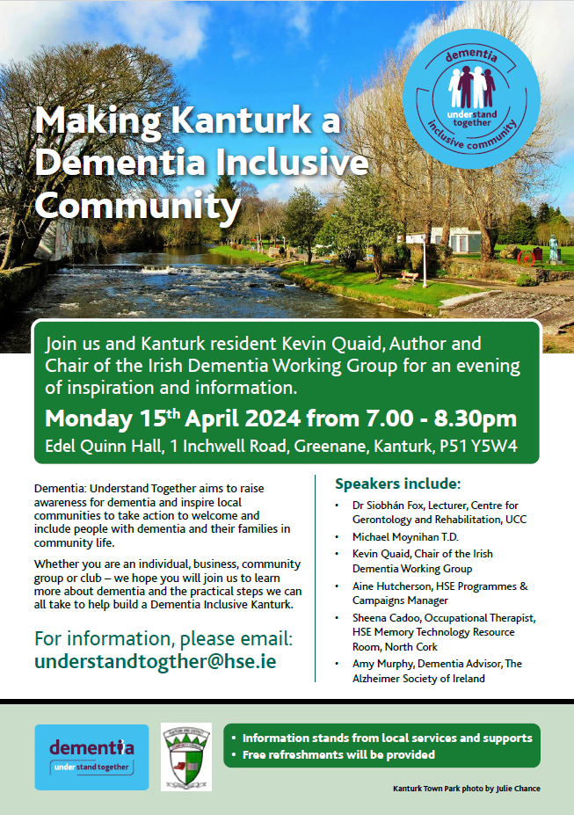

Includes, bright community image of recognisable landmark or location

Dementia Inclusive symbol is displayed clearly

The what, where and when are front and centre and clear

Bullets used to break up text and give definition to important information

Contact /Call to action is larger

Space for logos – choose the most relevant

Credit for use of image included

# **Using images to help tell your story**

You should only use graphics and images that you own, or have been given permission to use from the owner. If in doubt, don’t use it.

Use inclusive imagery that is representative of Ireland’s diverse communities and respectful of the many people and families affected by different types of dementia.

We know that there can be an assumption that only much older people have dementia. While we know that this is more likely, we also know that older people don’t always see themselves as being in older age. Images used to portray a person with dementia should be adults 40+.

**Links to credit free inclusive images:**

* <https://www.agewithoutlimits.org/image-library> - create an account to download images for free
* <https://www.publichealth.ie/gallery> - please email [communications@publichealth.ie](mailto:communications@publichealth.ie) to request images in high resolution, without watermark, for use in your own projects and resources.

**Top tips for creating great images:**

* Use real people and activities or events if you can, try and steer away from ‘staged photos’ of models (ensure you have permission to use the images)
* Think positive, use bright colours and images that are light to draw the eye
* People are particularly drawn to images that show faces or expressions
* If you use text on your image, make sure it’s clear and easy to read, use a contrasting colour font to improve accessibility
* Check that your image appears in the correct format on all channels you are using as Facebook, Instagram and Twitter/X may have different size requirements.

**Some key image dos and don’ts:**

|  |  |
| --- | --- |
| **Do** | **Don’t** |
| Show positive aging – people living day to day life well | Use images of people with grey hair or of older appearance to represent people with dementia |
| Show older people being active and interacting with others. Consider intergenerational images | Use images of people looking distressed, holding head in hands, crying |
| Make images about the community – could you use a photo of a local landmark or of people interacting at one of your events or activities (both with permission) | Use images where part of the head/mind/brain isn’t included, blurred or moving away – we have feedback from people with dementia that this is unhelpful and can cause upset |
| Use images that represent the backdrop of Ireland and Irish communities. Consideration for seasons/weather | Use images of body parts such as hands holding, or symbols that might not be clear in meaning |
|  | Use blurry or low resolution graphics or images |

# **Dementia inclusive and accessible language**

It is important that our all of our communications use dementia inclusive language.

We want to use words that do not stigmatise and are positive, representative and empower people with dementia and their families, friends, carers and supporters.

* Use positive and inclusive language.
* Write in plain English and do not use overly complicated language. This guidance from the National Adult Literacy Agency (NALA) may be useful: <https://www.nala.ie/plain-english/plain-english-tips/>
* Spell out acronyms when using for the first time.

**Some key language dos and don’ts:**

|  |  |
| --- | --- |
| **Do use** | **Don’t use** |
| Dementia/a form or type of dementia/symptoms of dementia | Dementing illness, demented, affliction, senile dementia, senility |
| Condition | Disease, illness |
| Person/people with dementia, living with dementia, people with a diagnosis of dementia | Sufferer, suffering, sufferers, demented sufferers, vacant, victim, demented person, patient, subject, case |
| Life changing, can be challenging | Hopeless, unbearable, impossible, tragic, terrible, devastating, painful, distressing, fading away, empty shell, not all there, losing it, disappearing, stealing them away, mini death, death sentence, the longest goodbye – only exception to this is if people with dementia and/or their families choose this language in video content or a quote as it’s in their own words/perspective |
| Family of/family member/s or person caring/supporting someone living with dementia  Wife, husband, partner, child, friend etc. | Those caring to support, family of those with dementia |
| Impact/effect of supporting someone with dementia | Carer burden, burden of caring |
| Behavioural and Psychological Symptoms of Dementia (BPSD), changed behaviour, challenging or difficult communication | Aggressive, wanderer, poor feeder, wetter or incontinent, obstructive, non–communicator, attention-seekers, non-communicators, obstructive, etc. |

# **Using the Dementia Inclusive Community symbol in your communications and promotions**

As well as displaying and using the Dementia Inclusive Community at your premises, meeting places, services, events and online – please try to include the symbol in all of your promotional materials.

This helps to strengthen awareness of the symbol and shows that you are connected to the national movement.

When something includes the symbol, the campaign logo can be removed to save space/declutter.

**Download the symbol here:**

[**https://www.understandtogether.ie/training-resources/helpful-resources/publications/guidance-and-guidelines/understand-together-community-symbol.png**](https://www.understandtogether.ie/training-resources/helpful-resources/publications/guidance-and-guidelines/understand-together-community-symbol.png)

**When to include the Dementia Inclusive Community symbol:**

* On any promotional materials, websites, newsletters, social media, posters and flyers
* When promoting or talking about any community based activity – crafts, walking, sport, exercise, being outdoors, socialising, being with family, friends
* In promotion or news of dementia inclusive community focussed events and activities such as awareness events and training opportunities.

**Download brand guidelines for the Dementia: Understand Together logo and Dementia Inclusive Community symbol here:**

[**www.understandtogether.ie/training-resources/training-and-resources.html**](http://www.understandtogether.ie/training-resources/training-and-resources.html)

For advice on developing any promotional material using the symbol, please email: [**understandtogether@hse.ie**](mailto:understandtogether@hse.ie)